 | Mental Recall | Maths  Oak Academy | English  Oak Academy | Wider Curriculum  Oak Academy | Study Ladder  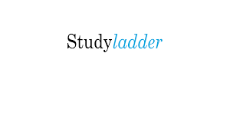 | Spellings  Reading  Projects
Mon | Mathletics  TT Rockstars  Weekly Mental Maths | Addition | Past and present tense | RE | Grammar and punctuation | See home learning books for projects and spellings.
Tues |  | Addition | Past and present tense | Science | Word Building
Wed |  | Subtraction | Past and present tense | PSHE | Synonyms
Thurs |  | Addition | Past and present tense | French | Poetry
Fri |  | Addition | Word classes | Science | Grammar and Punctuation

